**CIS 572 Object Oriented System Design**

**Forward Tracing**

**For**

**Add Member (Manage Members ~~Registration~~)**



Submitted to:  Mr. Thomas Steiner

~~Submitted by: Tejaswi Dasyam~~

~~UMID 46593216~~

**Table of Contents**

1. USE CASE FLOW 3

2. USE CASE DIAGRAM 3

3. BUILD ERD 4

4. ROBUSTNESS DIAGRAM 5

5. COMMUNICATION DIAGRAM 5

6. SEQUENCE DIAGRAM 6

7. CLASS DIAGRAM 6

8. DFD 7

9. STATE DIAGRAM 7

10. CRC CARD 8

11. INTERFACE 8

# 1. USE CASE FLOW

* 1. Add Member:
     1. Member will provide the required details like Name, Email address, Phone number, Address to the operator.
     2. Operator will enter the member details on the terminal and submit.
     3. Member will be registered and the details of the record will be saved in the ChocAn data center system.

# 2. USE CASE DIAGRAM

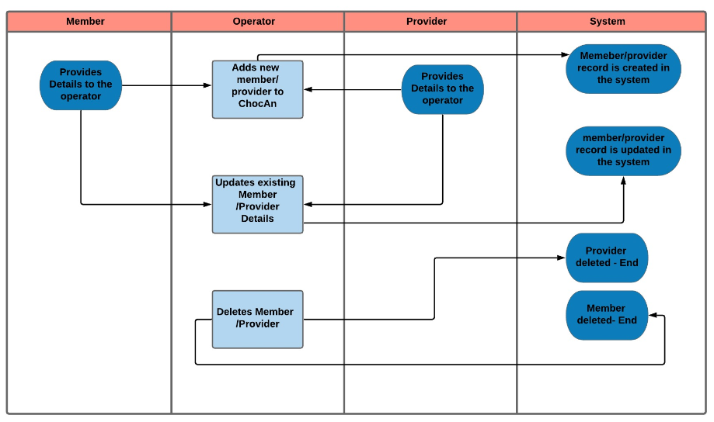

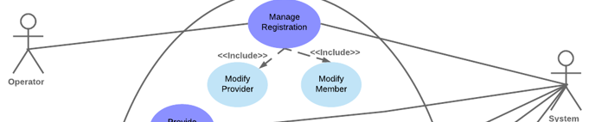

# 3. BUILD ERD

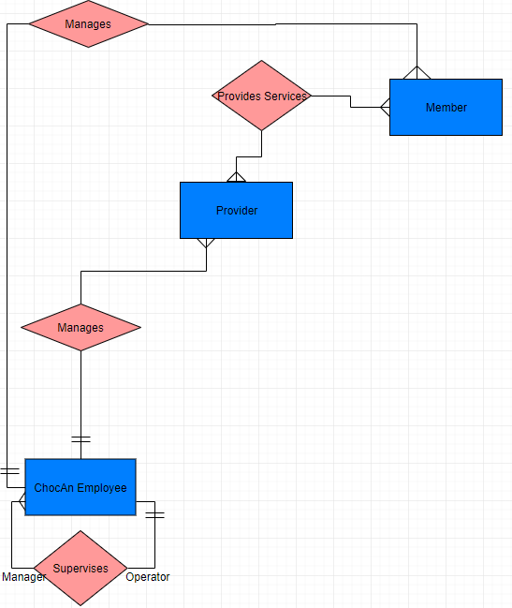

# 4. ROBUSTNESS DIAGRAM

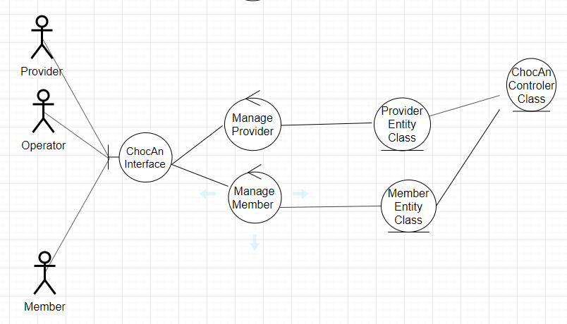

# 5. COMMUNICATION DIAGRAM

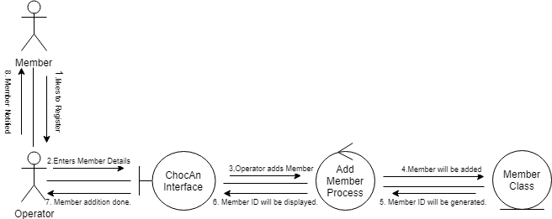

# 6. SEQUENCE DIAGRAM

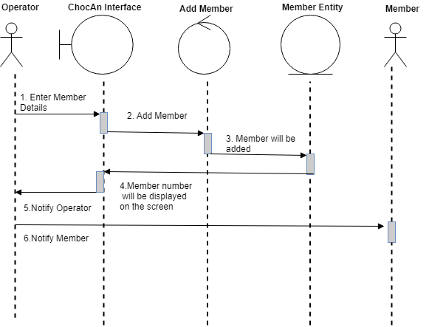

# 7. CLASS DIAGRAM

# [diagram below was deleted]

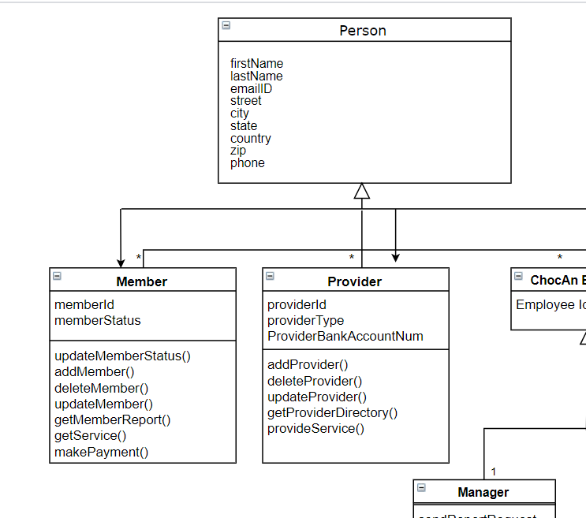

# 8. DFD

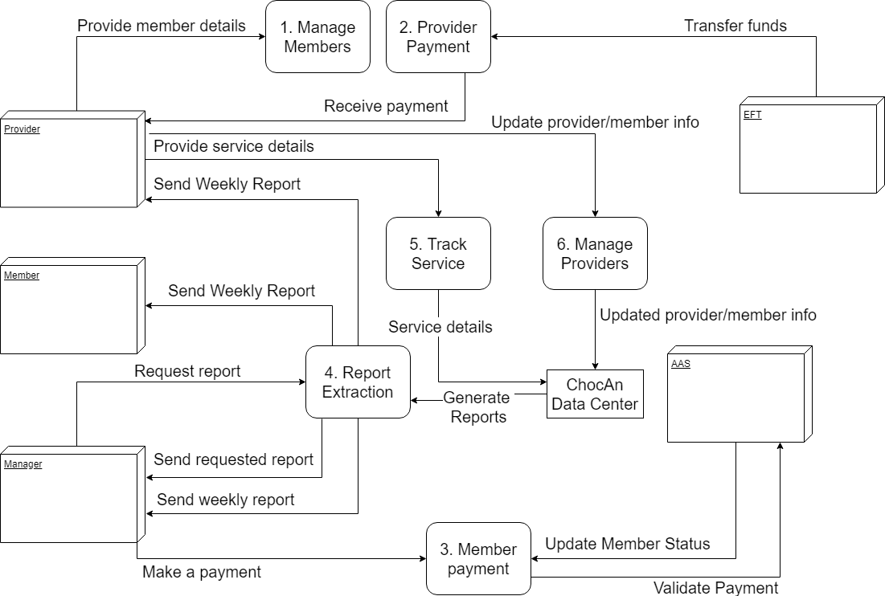  
[diagram below was deleted]

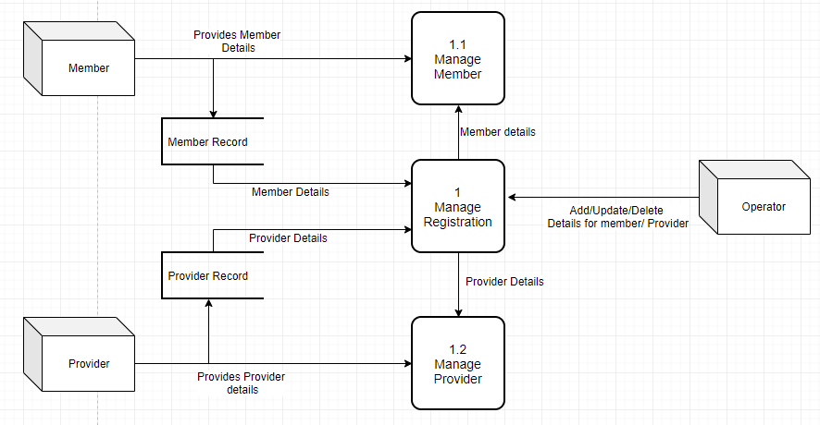

# 9. STATE DIAGRAM

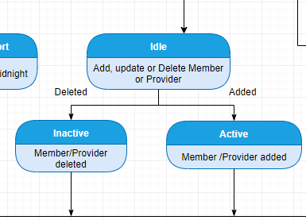

# 10. CRC CARD

|  |  |
| --- | --- |
| Class: ManageMember Control, ManageProvider Control |  |
| Responsibility | Collaborators |
| addProvider(),deleteProvider(),updateProvider() addMember(),deleteMember(),updateMember() | Member Entity, Provider Entity |

# 11. INTERFACE

